**For 100 validation data ;**

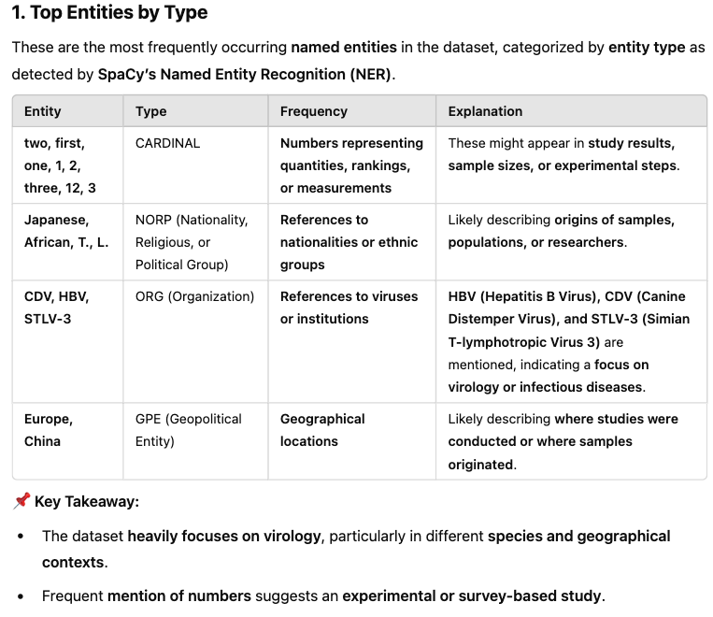

Hypergraphs, which generalize graphs by allowing hyperedges to connect multiple nodes, provide a more expressive framework for modeling such relationships \cite{berge1973graphs}. However, effectively mining insights from hypergraphs remains a challenge due to their high-dimensional nature and the lack of appropriate embedding techniques. While prior work has explored hyperspherical embeddings and Sphere Neural Networks (SNNs) \cite{dong2024sphere}, their potential for modeling hypergraphs remains largely unexplored.

To address this, we present a **new application of hyperspherical deep learning to hypergraph analysis**, integrating geometric hypergraph mining \cite{montesihypergraph} with Sphere Neural Networks (SNNs), a class of neural networks designed for hyperspherical spaces. By embedding hypergraph structures into a hyperspherical space \cite{montesihypergraph}, our approach captures both geometric and relational properties, enabling robust analysis of web-based datasets.

Our contributions are threefold:

\begin{enumerate}



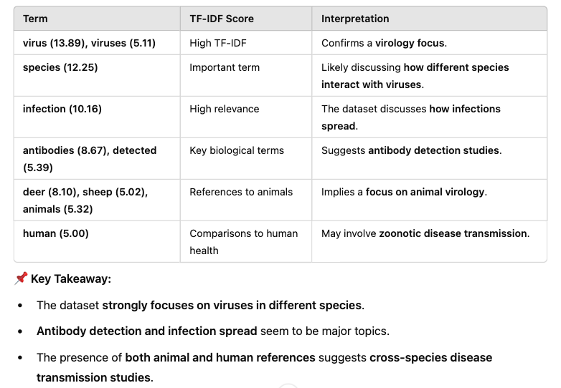

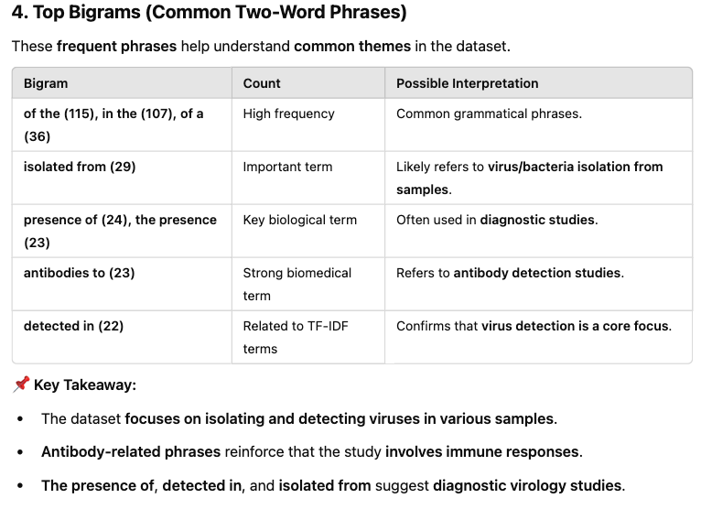

**For all data:**

